I’m thinking about having my Robot drive around the room, and having it serve up a web page via Wi-Fi using:

[RN-XV WiFly Module - Wire Antenna](https://www.sparkfun.com/products/10822)

so my classmates can drive my Robot around the classroom, and send it queries, i.e., about its location, etc., via a simple web page like this:

<http://www.instructables.com/id/Control-Your-project-from-Wifly-Webserver/>

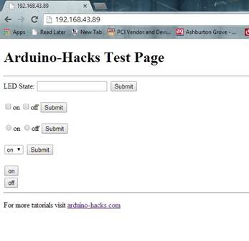

I want to have it send a JavaScript web page to the user, that draws the path of the robot around the room, and hopefully map out the room walls accurately using Sonar and 3-Axis Magnetometer, so it won’t get lost ☺.

=Cliff

P.S>Final Project Notes below:

Classroom Explorer

I have one of these already with a LPC1768 on it:

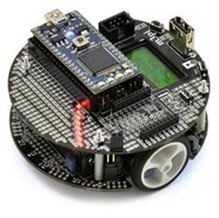

[m3pi Robot + mbed NXP LPC1768 Development Board Combo](https://www.pololu.com/product/2153)

that I’d like to stack one or two of these decks on top of it to mount sensors on.  I have standoffs and screw hardware already, and we can always buy more cheaply at Halted, aka HSC:

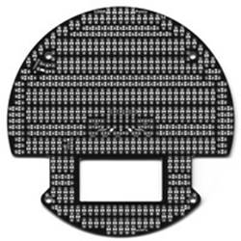

[3pi Expansion Kit with Cutouts - Black](https://www.pololu.com/product/979)

I propose to add some I2C Sensors, i.e., a 3-D Compass + Sonar, and IR Transceivers (which I already have), to have it crudely navigate around our classroom (just following walls, and maybe a bit of fumbling around under the desks, if there’s time to implement “extra credit”), and hopefully return to the corner we start it from.

The IR Transceivers can both detect Tangential Wall collisions (using super-bright IR LEDs), as well as exchange IR messages with other Projects that want to incorporate my Arduino code, which I’ve posted about and will provide on request.

I have two XBee Transceivers, this USB dongle 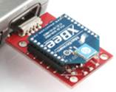.  The Robot above has a XBee Socket, so we can receive Room Map Data from it as it explores the room, and maybe send it help to find its way home when it gets lost.

The XBee may be too much of a drain on the Robot’s two AAA NiMH batteries, so we may need to add batteries if we want it to last more than 5 minutes.  Possibly we can have the Robot programmatically power-down the XBee most of the time when it doesn’t need to “phone” for help to find its way back home.

I have a 5000-line Java Program Robot Control Program already written, as described here:

<http://www.cliffolling.com/ArukuGo/>

<http://letsmakerobots.com/node/35134>

that I can adapt to run this small Robot, and receive and display Mapping data from it.

If you’re interested, let me know what I2C components you’d like to add, what you’d like to do with them, and if you’re more interested in autonomous, semi-autonomous, or fully remotely-controlled operation.

Lastly, if the above proves too ambitious for the time available to us, we can just have the Robot spin around (it can rotate _very_ fast) and spell out messages on its strip of LED’s, thanks to Retinal Persistence.

Something new I’d like to try, is via one of the Radios that Sheng-Liang listed:

[RN-XV WiFly Module - Wire Antenna](https://www.sparkfun.com/products/10822)

Make a web page somewhere, and from it, send commands and receive data from my LPC1768 via Wi-Fi, as described here:

<http://www.instructables.com/id/Control-Your-project-from-Wifly-Webserver/>

Hopefully there’s a “real” library available that answers GET’s, PUT’s, POST’s, etc., received thru the WiFly and my Wi-Fi from my little controlling Web Page.

Hmm, these are getting closer:

<http://playground.arduino.cc/Code/WiflyTemperatureServer>

<http://jamesgregson.blogspot.com/2013/03/minimal-http-server-example-with-wifly.html>

<http://codebrane.com/blog/2014/04/27/arduino-mega-web-server-with-wifly-and-temperature-sensor/>